Day Three Problems

Patent Fundamentals Bootcamp 2021:
An Introduction to Patent Drafting, Prosecution, and Litigation

June 4, 2021

DAY 3 PROBLEM

Attached is a fax from a client seeking litigation advice. The client attaches a copy of a web page showing a chair from a website of a competitor that may infringe our new patent. Please:

- Prepare an INFRINGEMENT claim chart to determine whether they infringe the '210 patent (use the template provided); students with last names beginning in A-L should take a "narrow construction" position of the claim element; students with last names beginning in M-Z should take a "broad construction" position of the claim element.

- Prepare an INVALIDITY claim chart (in same table) to determine whether the web page chair anticipates or renders obvious the claims (use the template provided); students with last names beginning in A-L should take a "narrow construction" position of the claim element; students with last names beginning in M-Z should take a "broad construction" position of the claim element.

Acme Seating, Inc.
53 San Carlos St. San Jose, CA 95192

FACSIMILE COVER SHEET

Date: | May 6, 2017
To: | Patent Attorney
From: | Company President
Re: | Chair Patent

Message:

See attached Flyer. These guys are ripping me off. Can we stop them based on the Chair Patent? How much will it cost? I would like to get licensing royalties, but cannot afford a lawsuit right now, so be careful not to get us sued.

Please call me after you review the flyer.

The Senator Guest Chair
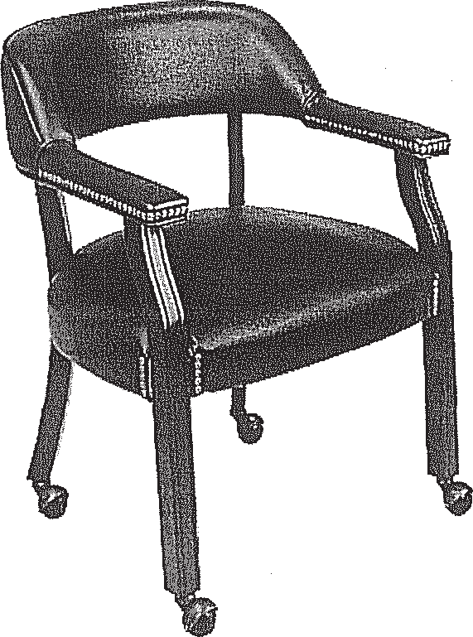

A comfortable guest chair to match your traditional decor. Features a wrap around back and padded armrests with brass tacks to top it off. Chair can be ordered with casters for mobility or without for stationary applications. Frame is finished in mahogany and also has brass tacks at the seat edges. 15 year warranty. Dimensions: Back Size: 23"W x 12.5"H x 3.5"Thick. Seat Size: 22"W x 20"0 x 4"Thick. Normal delivery time: 7-12 business days.

TV231Regular price: $139.99Sale price: $109.99

Claims | Claim Construction | Infringing Product
1. An apparatus comprising:

a substantially planar surface with a first
and a second surface; and

at least three elongate members, the
members each having a first end and a
second end, the first ends connected to the
first surface of the planar surface and
oriented with respect to the planar surface
such that the elongate members are
substantially perpendicular to the planar
surface and the elongate members are
substantially parallel to each other.

Claims | Claim Construction | Infringing Product
2. An apparatus according to claim 1,
further comprising a support member
connected to the second surface of the
planar surface and oriented in a direction
generally parallel to the elongate members.

Claims | Claim Construction | Infringing Product
3. An apparatus according to claim 1,
further comprising exactly three elongate
members.

Claims | Claim Construction | Infringing Product
4. An apparatus according to claim 1,
further comprising exactly four elongate
members.

5. An apparatus according to claim 1,
wherein the planar surface and elongate
members are wood.

6. An apparatus according to claim 1,
wherein the length of each of the elongate
members is approximately equal to the
distance between the knee and the ankle of
an adult human leg.

7. An apparatus according to claim 1,
wherein the area of the planar surface is
approximately equal to the area of the back
surface of an adult human buttock.

SAMPLE PATENT

For use by jurors viewing
An Introduction to the Patent System.

FJC videotape# 4342-V/02

These materials were produced by the Federal Judicial Center in furtherance of the Center's statutory mission to develop and conduct education programs. The views expressed are those of the authors and not necessarily those of the Federal Judicial Center.

Produced by the Federal Judicial Center
2002

