Advanced Patent Prosecution Workshop 2021:
Claim Drafting & Amendment Writing

Electromechanical
Problem Set

Table of Contents:
Problem #1
Problem #2
Problem #3
Problem #4

Electromechanical
Problem #1

Advanced Patent Prosecution Workshop 2021:
Claim Drafting & Amendment Writing

ADVANCED CLAIM DRAFTING AND AMENDMENT WRITING WORKSHOP
ELECTROMECHANICAL SECTION
HOMEWORK PROBLEM I

The attached disclosure discloses a workbench with two principal features: (1) a work surface formed by a pair of top members that also form a giant vice for gripping both tapered and regularly-shaped workpieces and (2) a collapsible base structure that permits the workbench to be collapsed when not in use to facilitate handling and storage.
Three relevant prior art patents are also enclosed- the Thomas, Fleming and Larson patents.
Assume that the disclosed workbench has been a commercial success and that it is expected that competing workbenches will soon be introduced to take advantage of the market created by the disclosed workbench. Prepare an appropriate set or sets of independent and dependent claims that are patentable over the enclosed prior art and fully protect the disclosed workbench. While providing coverage of the aforementioned principal features, try to anticipate how a competitor might vary the workbench design to avoid your claims.

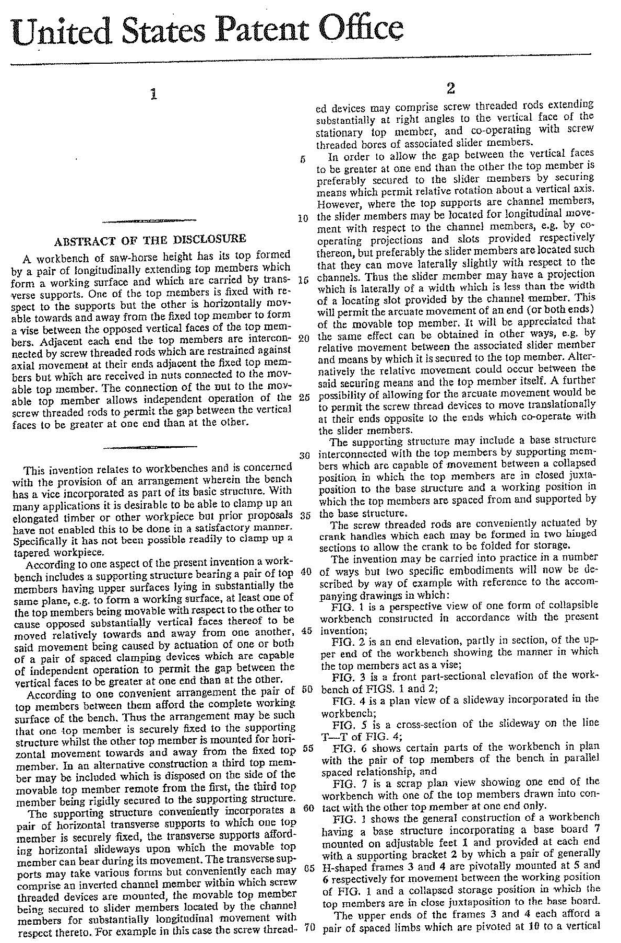

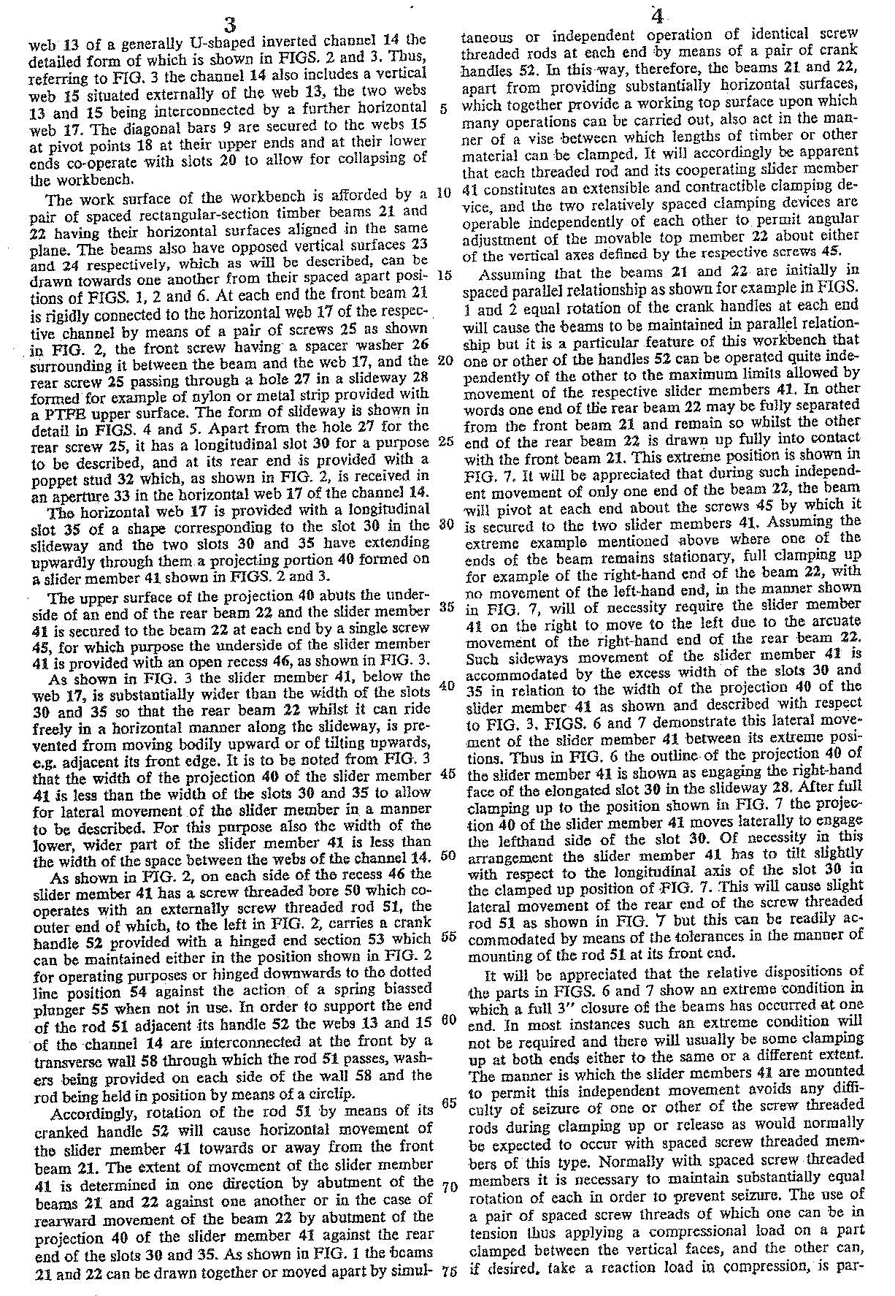

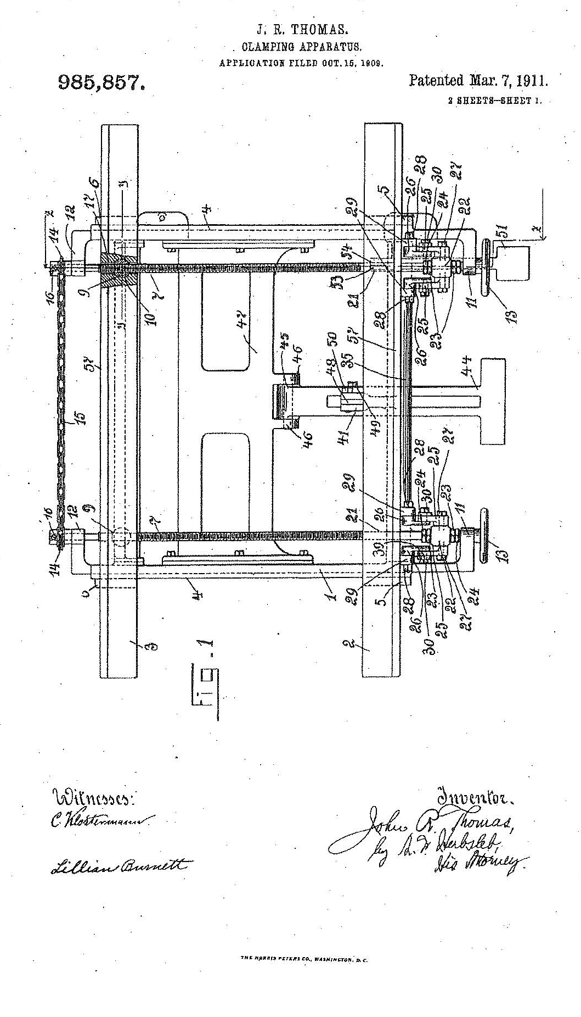

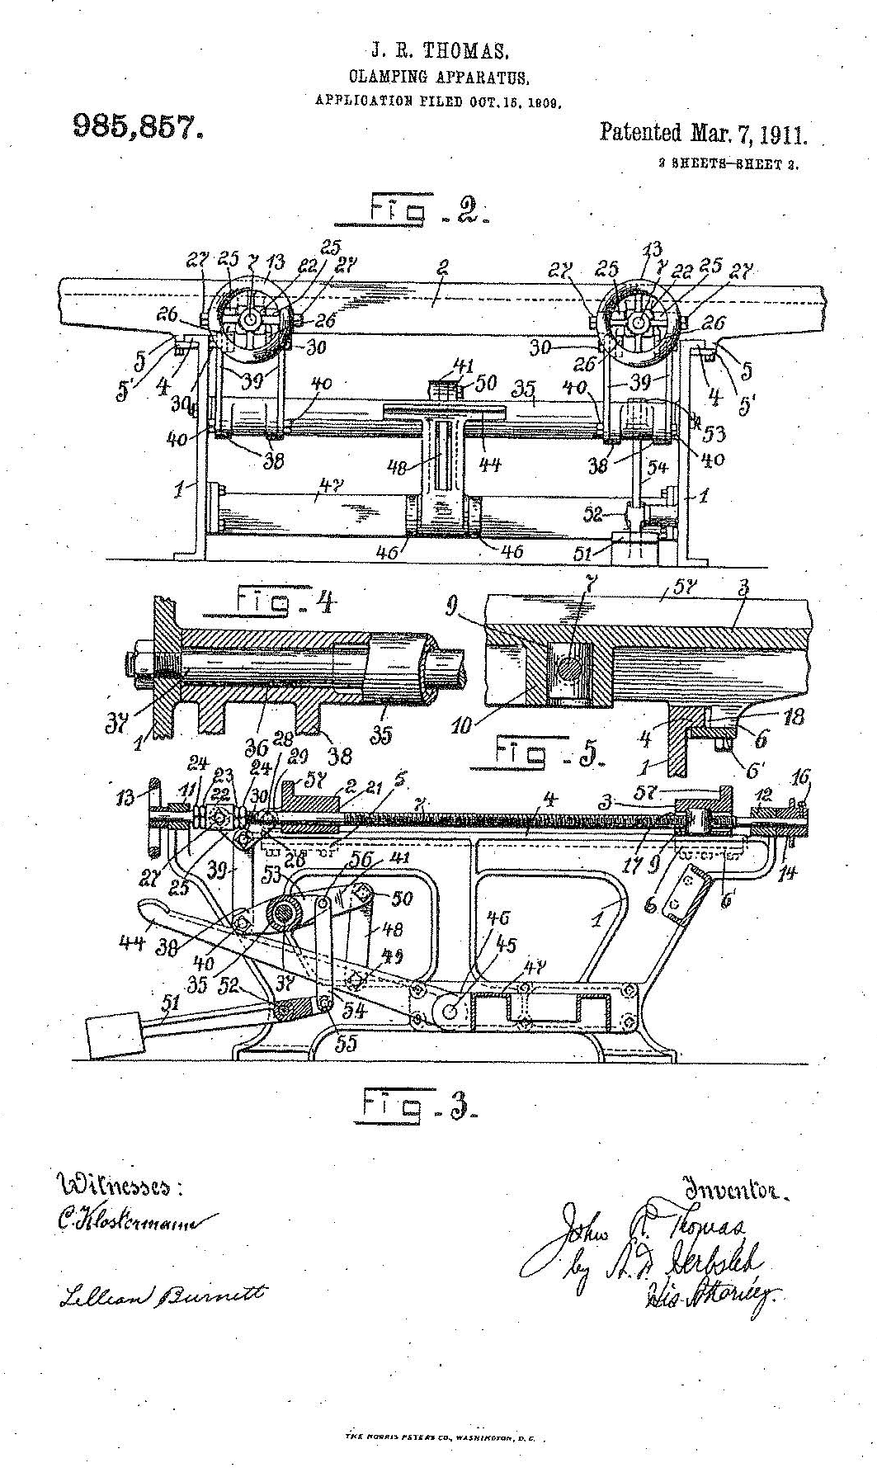

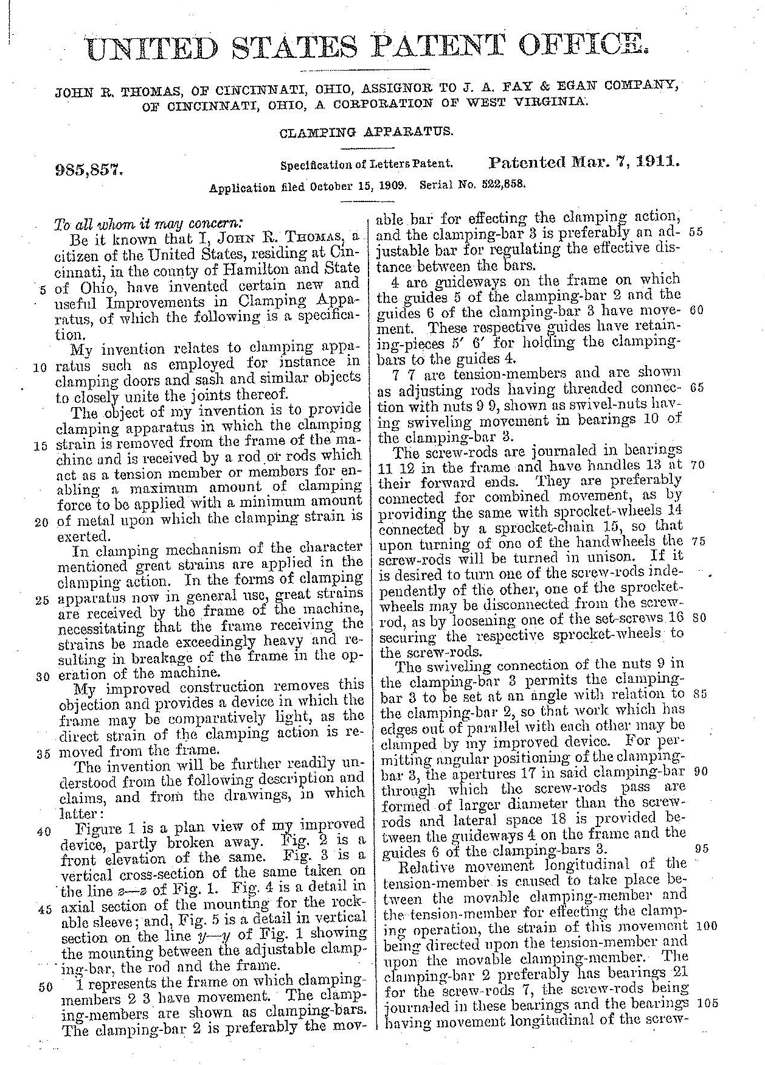

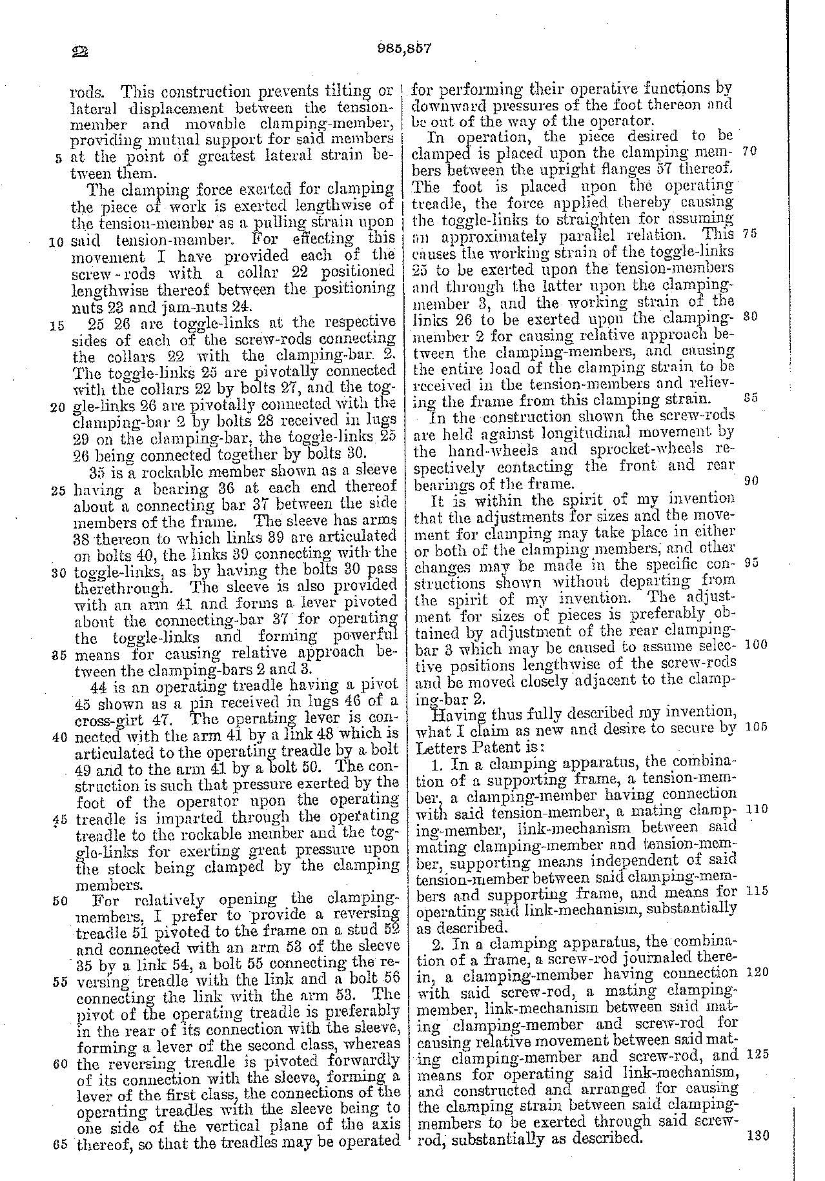

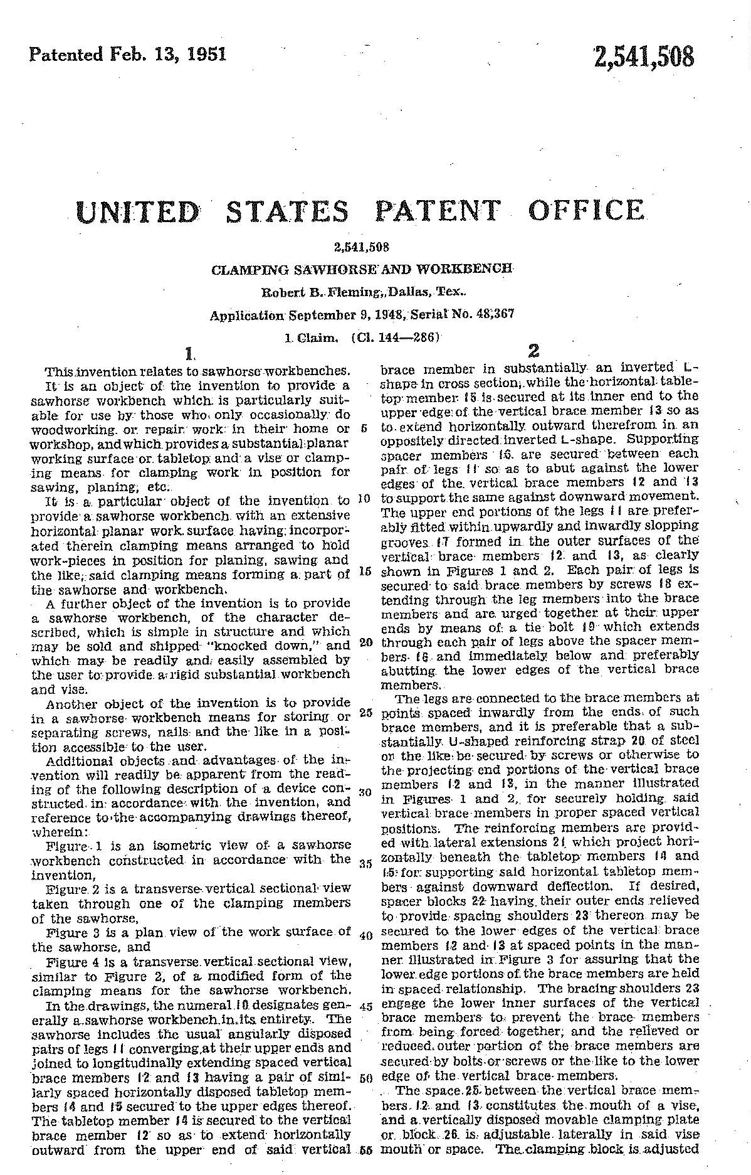

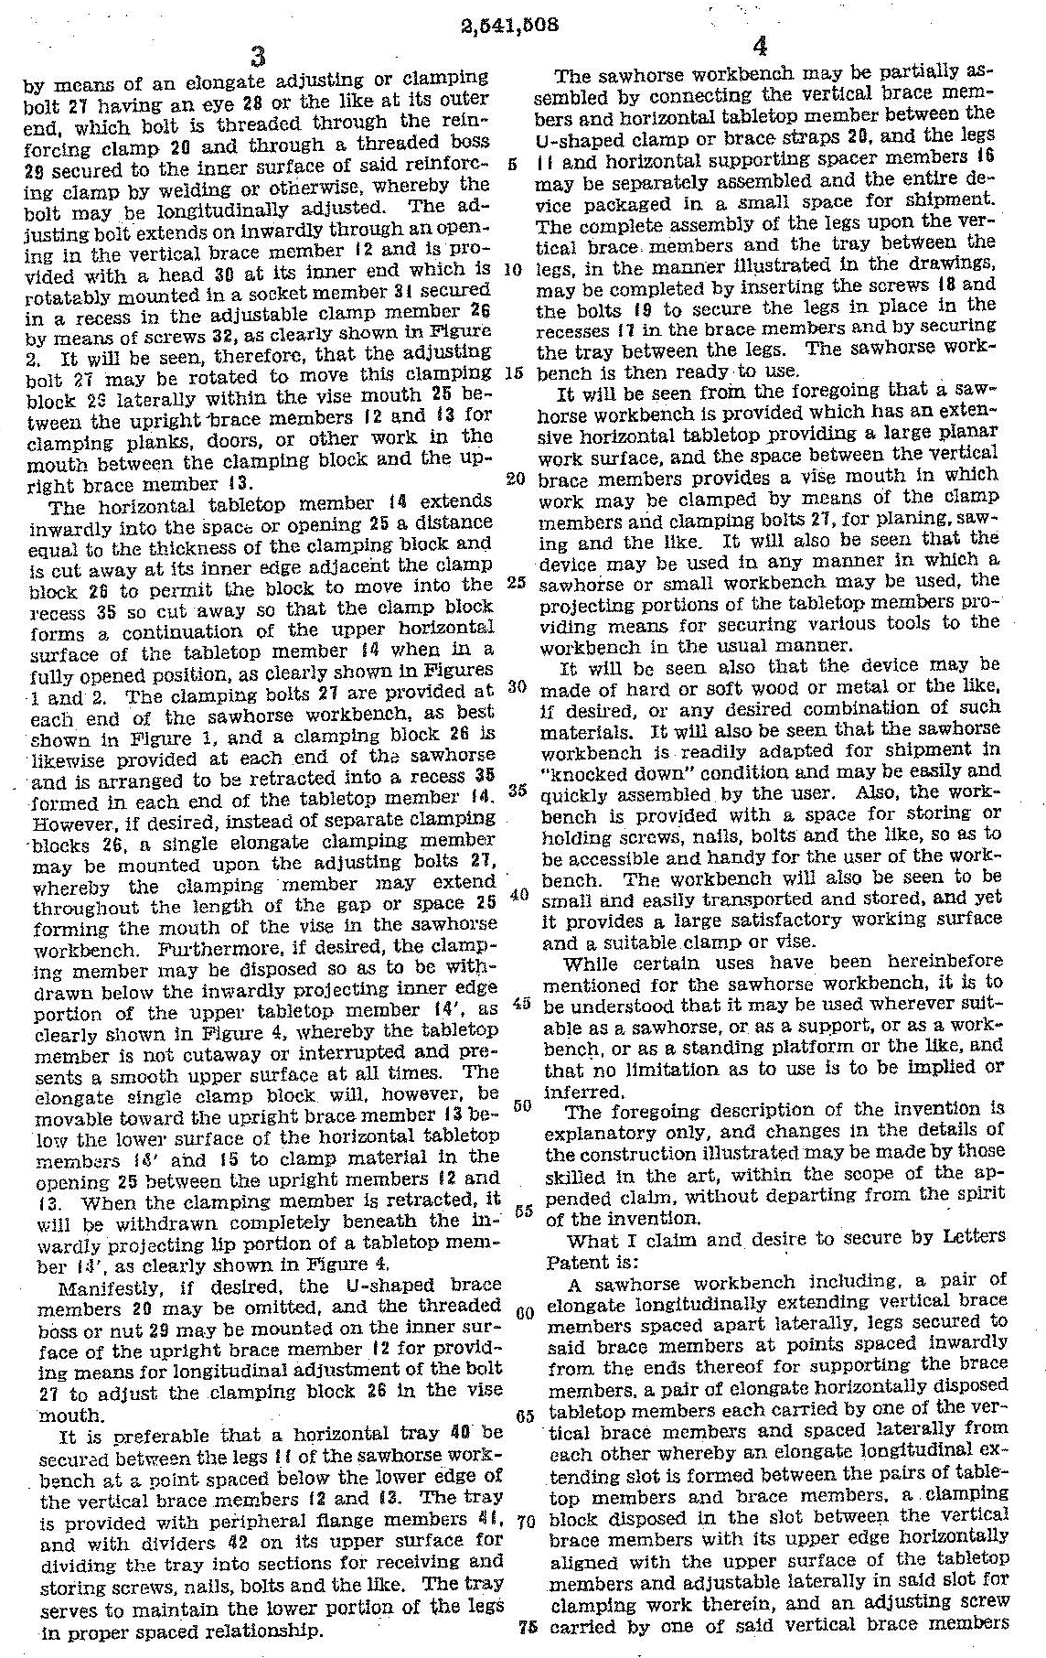

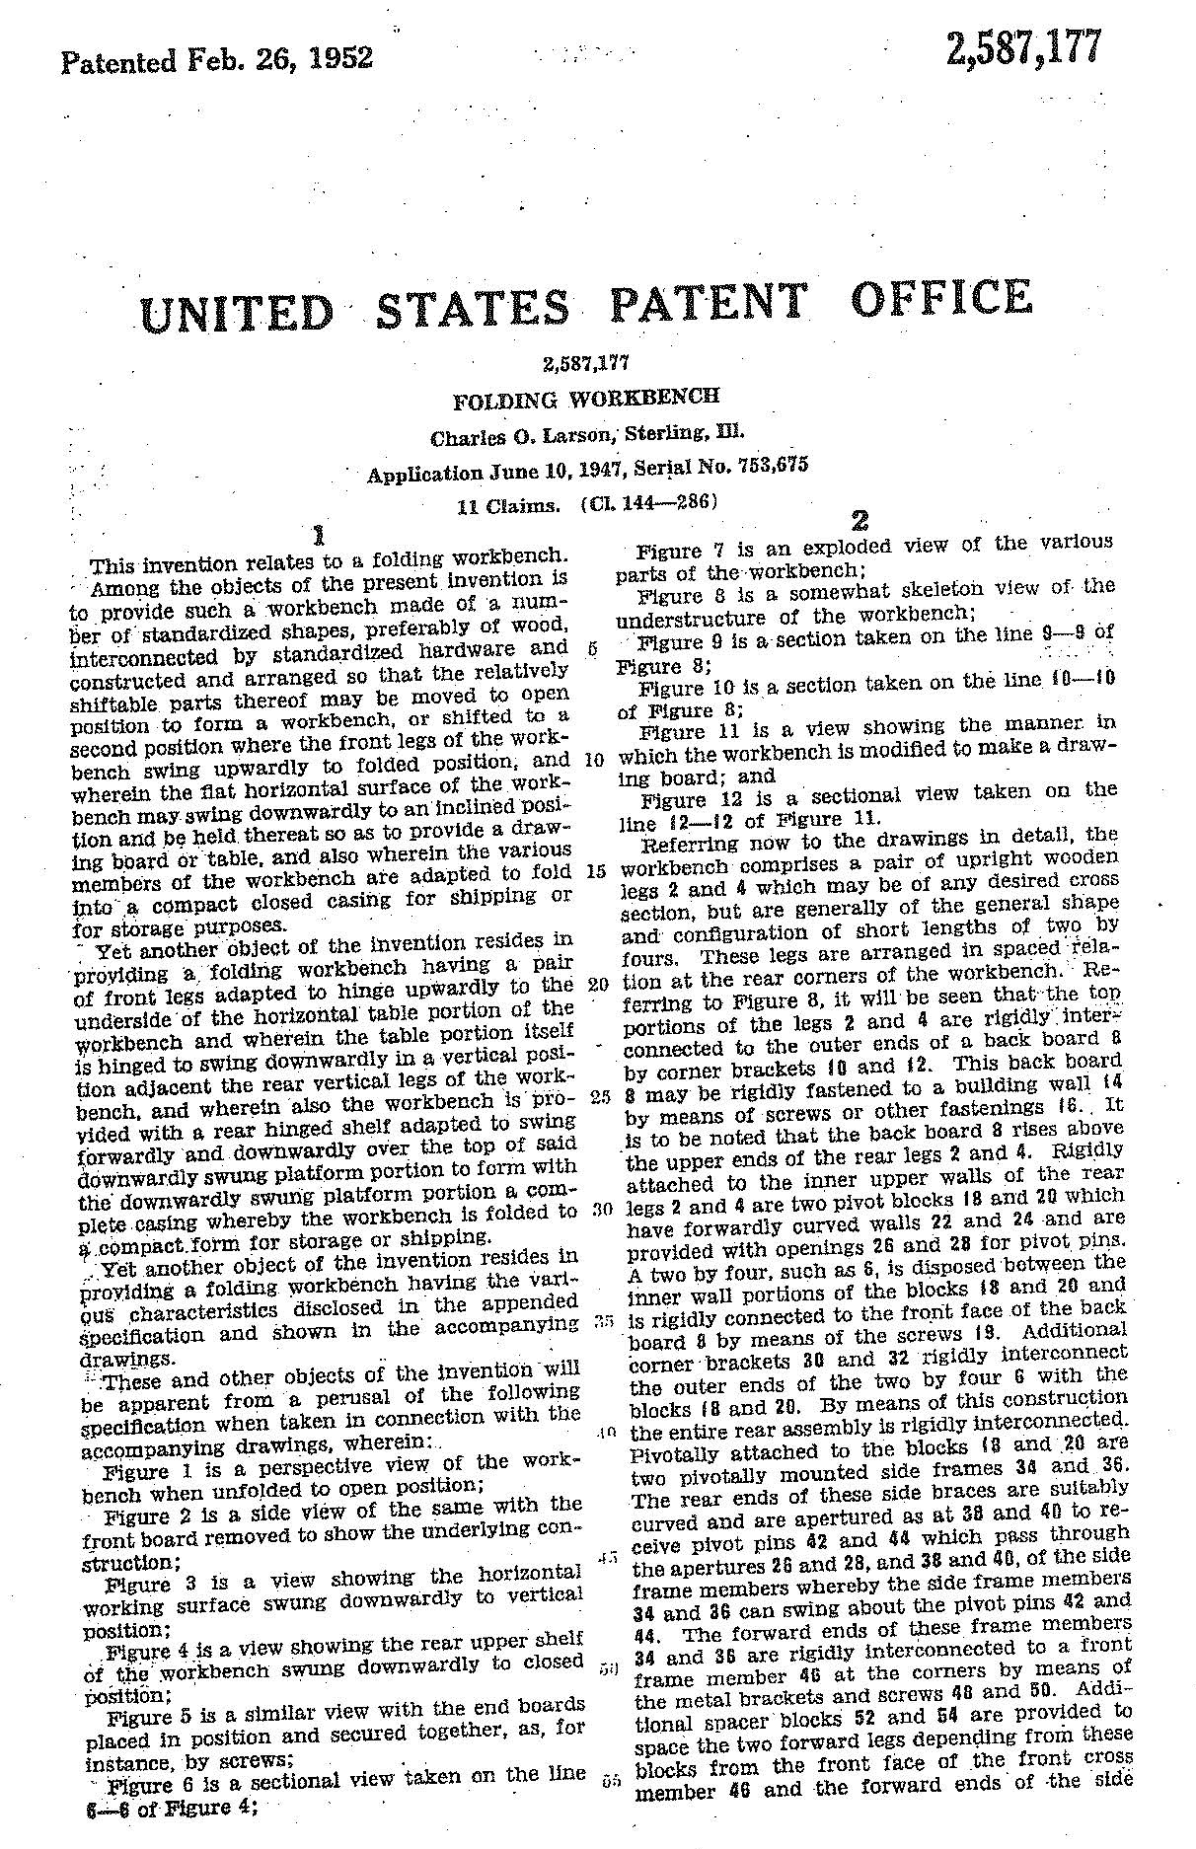

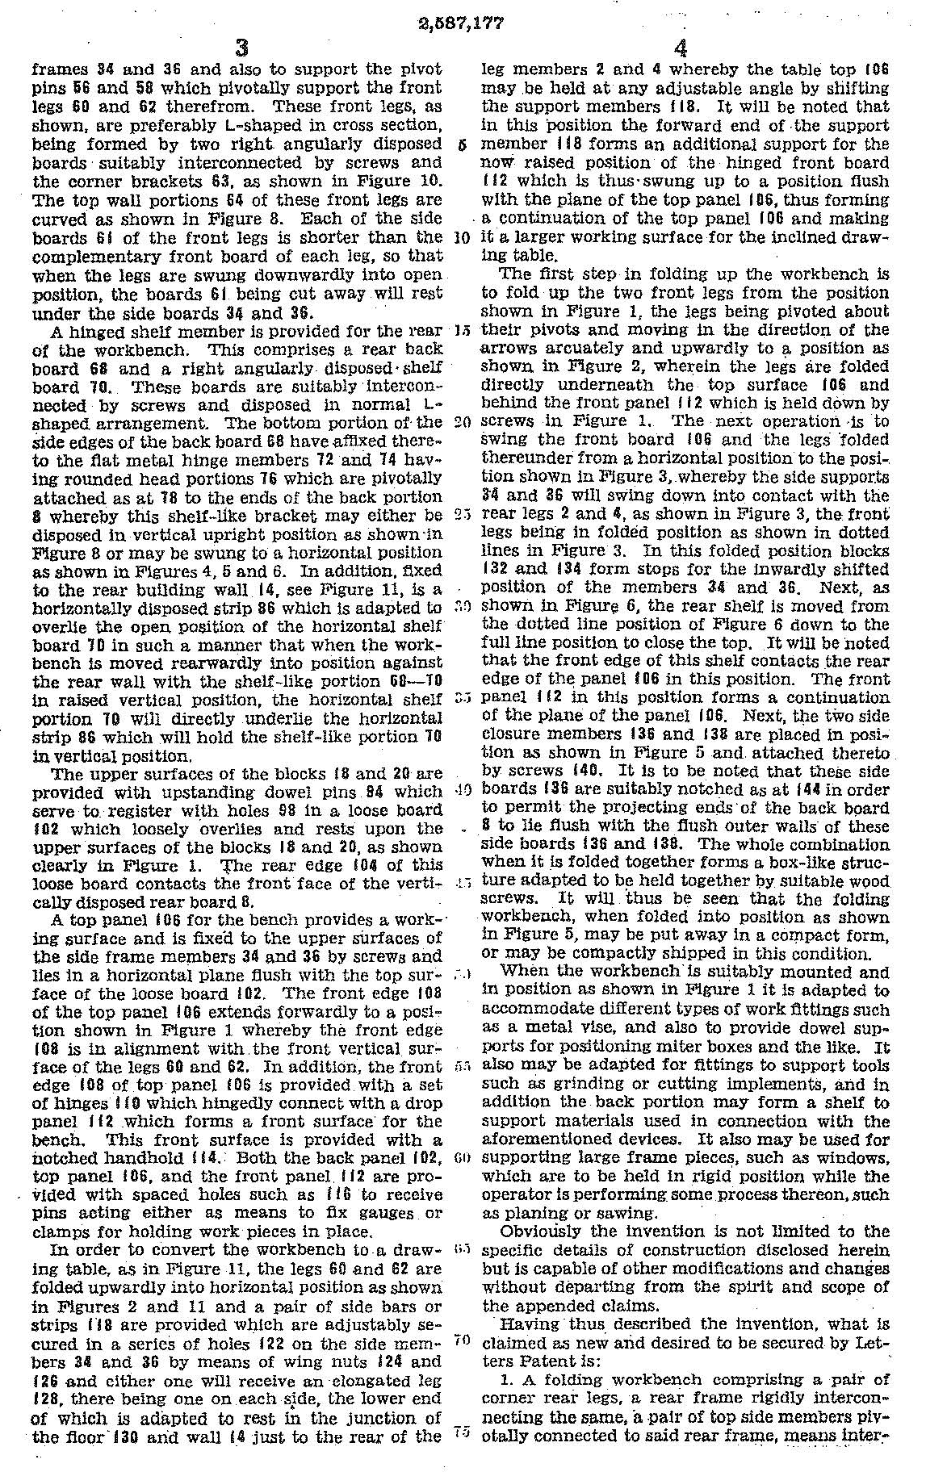

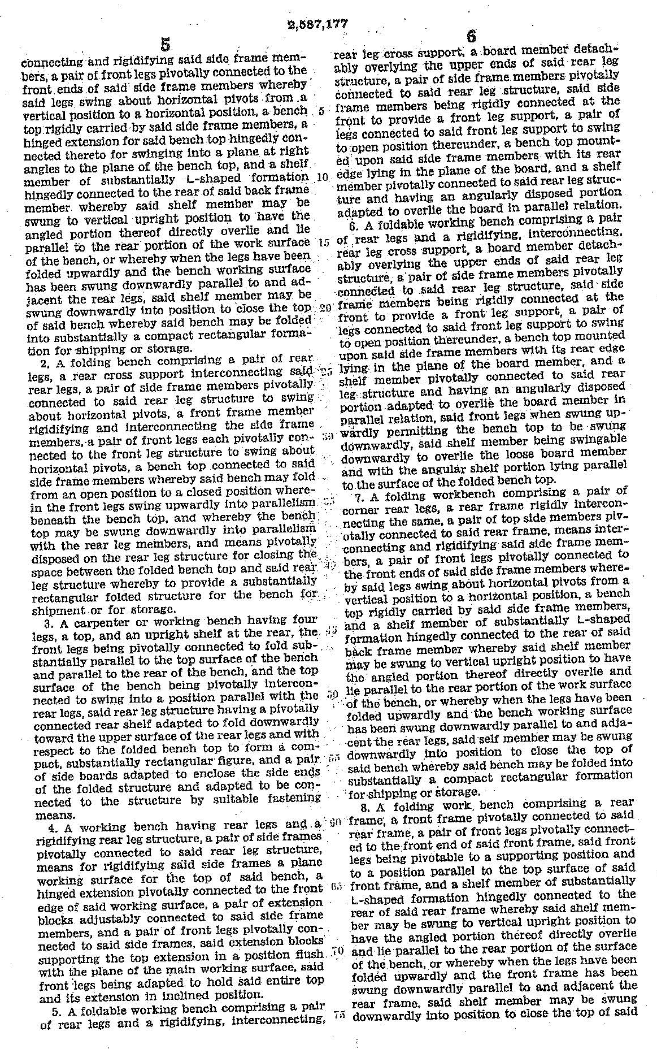

Electromechanical
Problem #2

Advanced Patent Prosecution Workshop 2021:
Claim Drafting & Amendment Writing

ADVANCED CLAIM DRAFTING AND AMENDMENT WRITING WORKSHOP
ELECTROMECHANICAL SECTION
HOMEWORK PROBLEM II

The attached specification and drawings disclose a push button electric switch.

The Finegan and Tsen et al. prior art references are also supplied so that you can write a broad claim that is distinguishable from the prior art.

Prepare a set of claims, including at least one broad independent claim covering the novel features of the invention.

Before beginning claim preparation, review all the patent disclosures, in order that you might direct the claims to the distinguishing features.

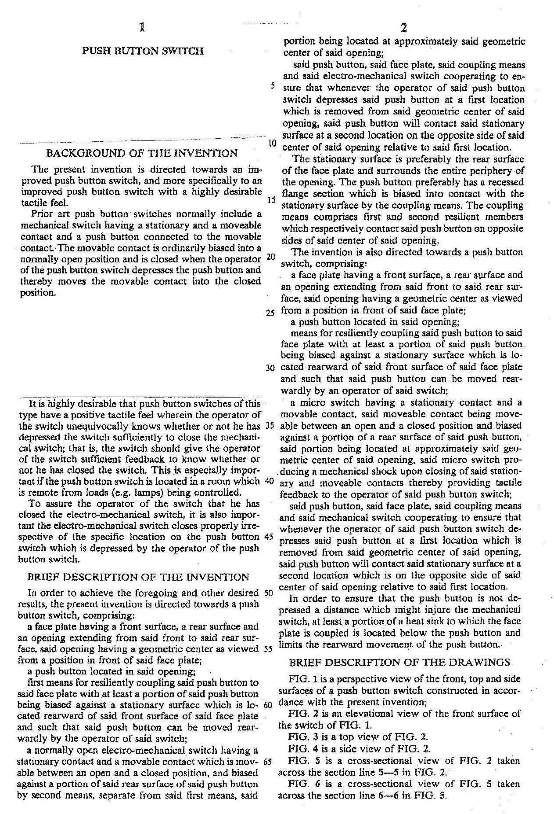

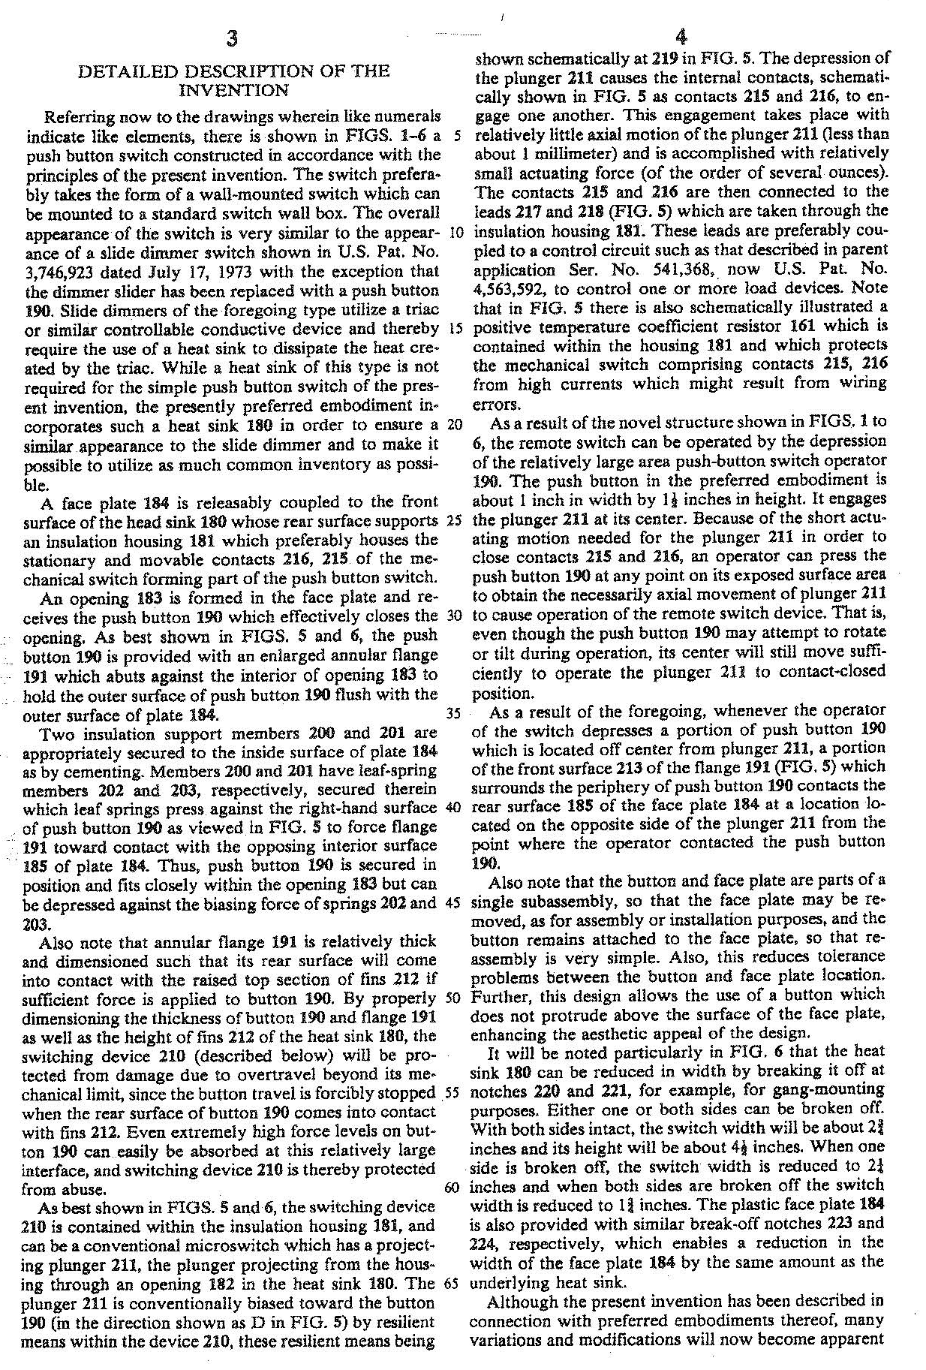

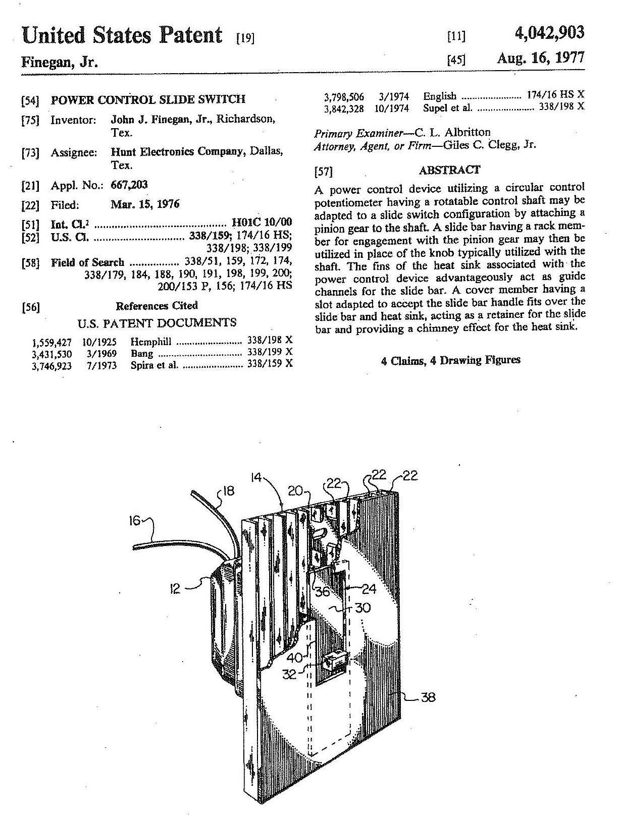

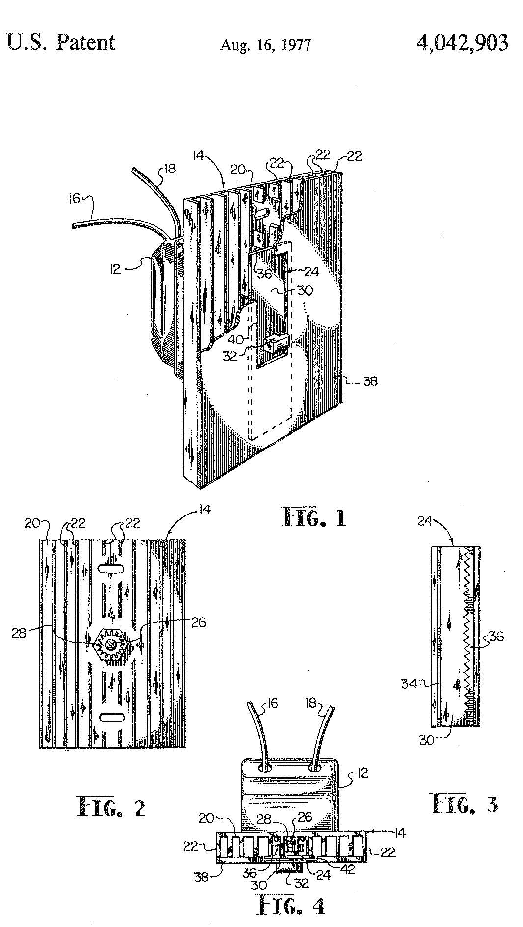

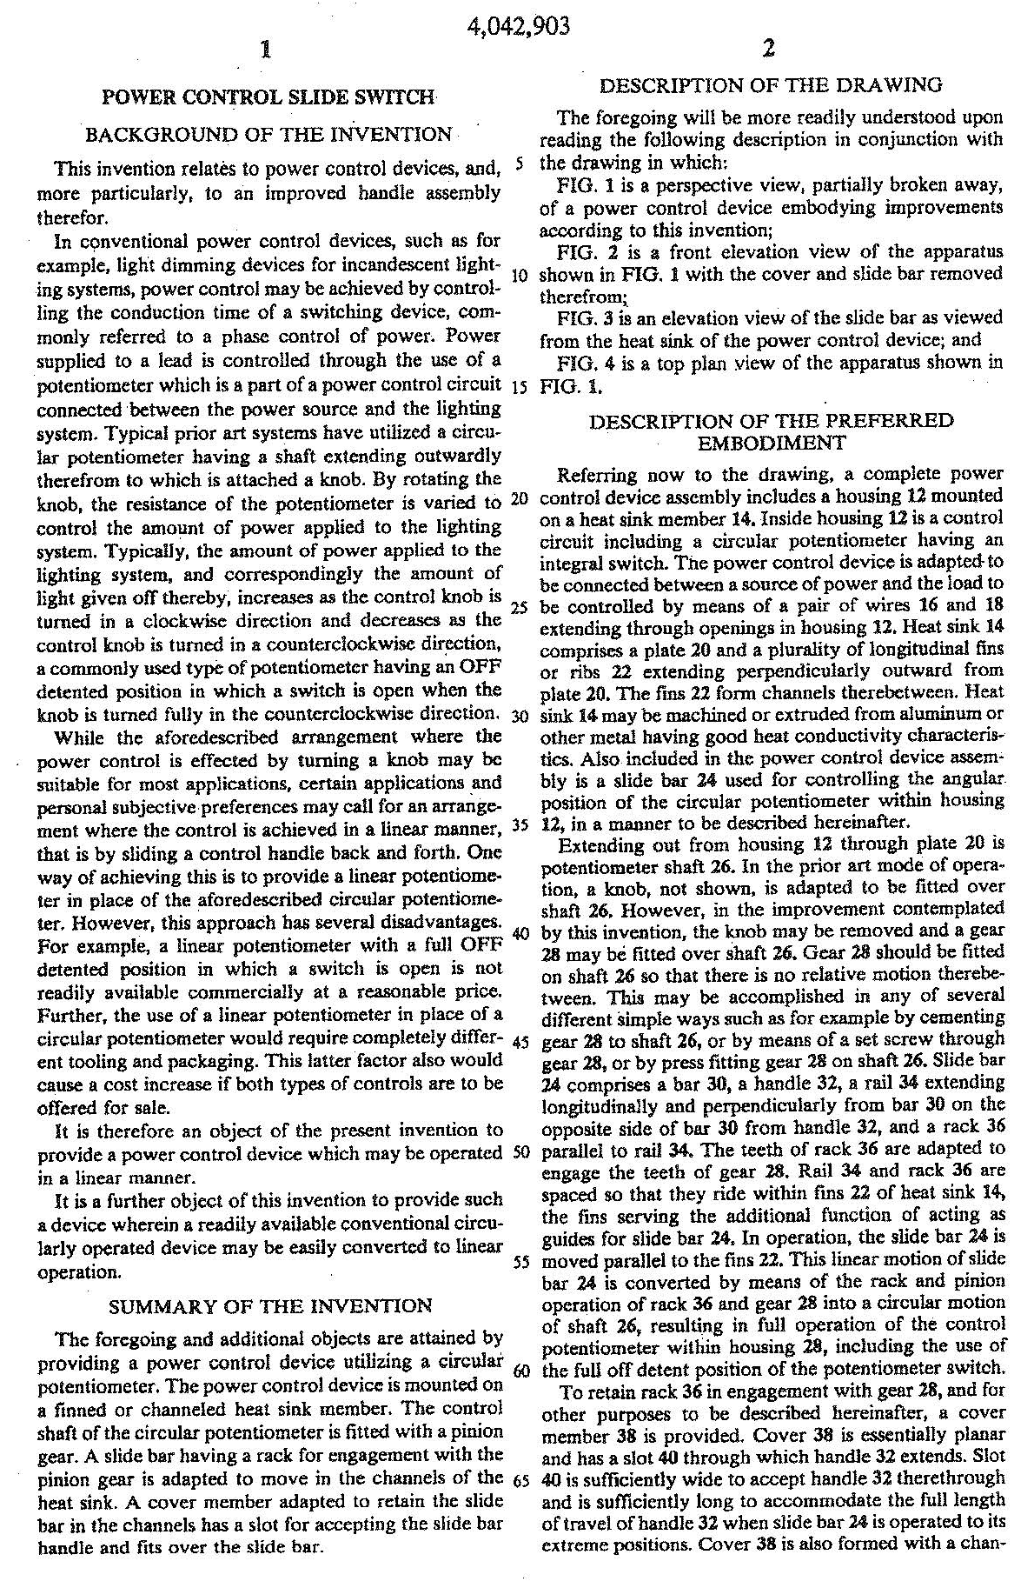

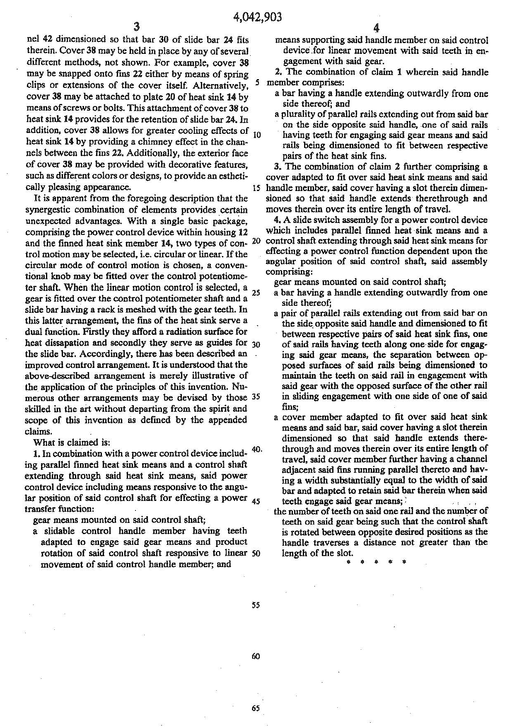

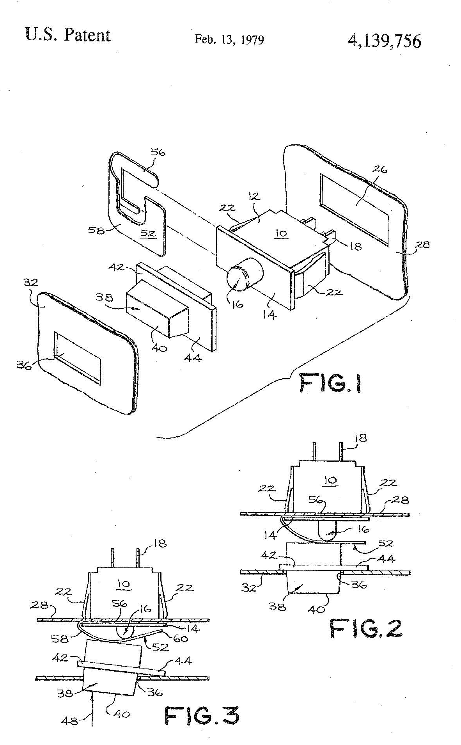

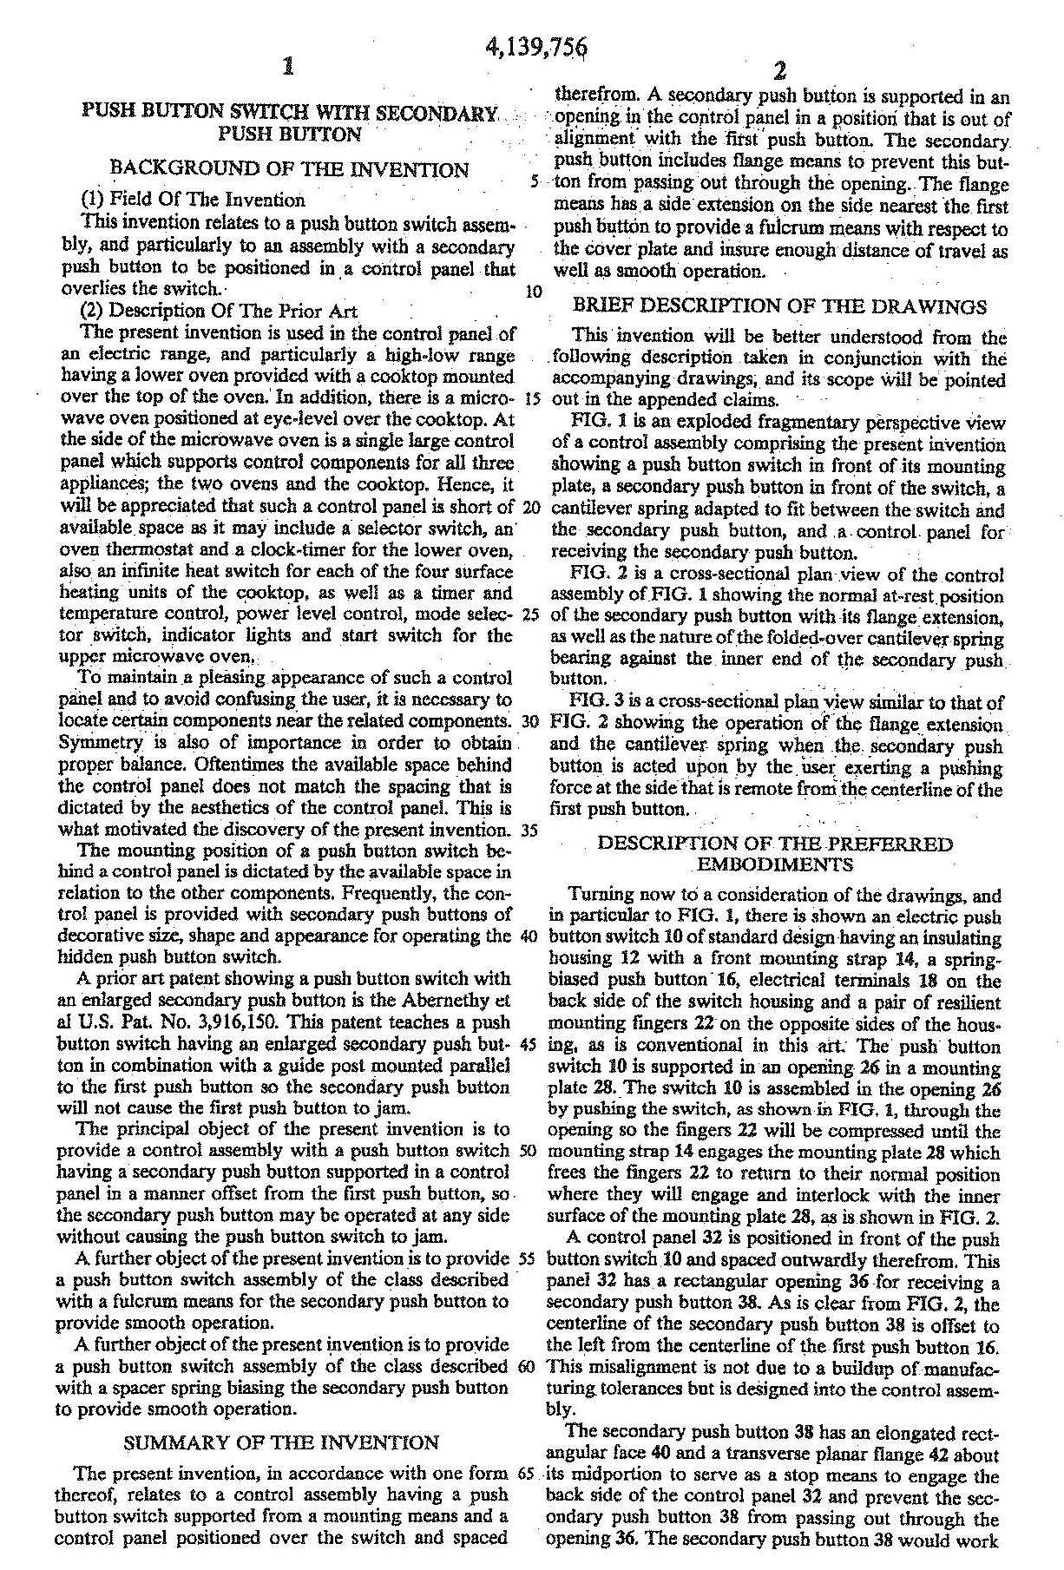

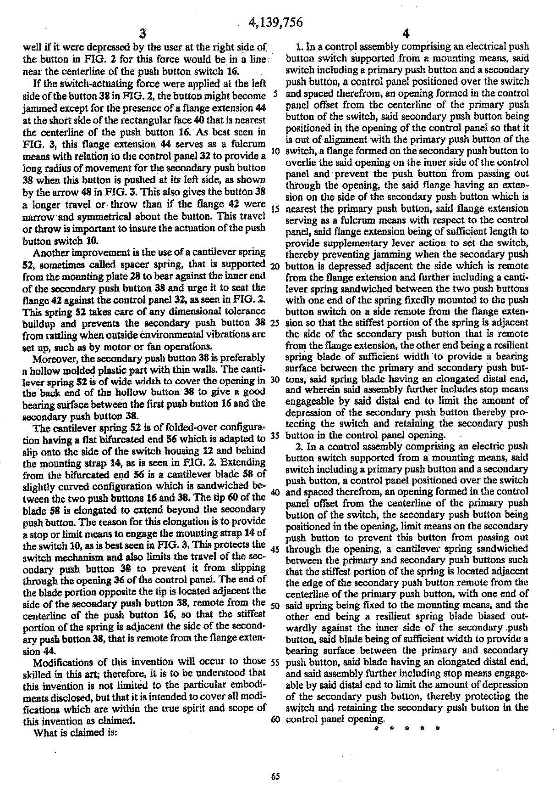

Electromechanical
Problem #3

Advanced Patent Prosecution Workshop 2021:
Claim Drafting & Amendment Writing

ADVANCED CLAIM DRAFTING AND AMENDMENT WRITING WORKSHOP
ELECTROMECHANICAL SECTION
HOMEWORK PROBLEM Ill

Assume that an application containing the work bench disclosure used in Problem I was filed with the claims attached as Appendix A. An Office Action attached as Appendix B, has been received in the application. Prepare an appropriate response
to the Office Action.

Appendix A

APPLICATION CLAIMS

1. A workbench including a supporting structure, a pair of top members carried by the supporting structure, the top members having opposed vertical faces thereof for forming a vice, at least one of the top members being movable with respect to the other to cause the said opposed substantially vertical faces to be moved relatively towards and away from one another, said movement being caused by actuation of one or both of a pair of spaced clamping devices which are capable of independent operation to permit the gap between the vertical faces to be greater at one end than at the other.

2. A workbench as in Claim 1 in which one of the vice members is secured in a stationary manner to the supporting structure and the other vice member is movable relatively to the supporting structure.

3. A workbench as in Claim 2 in which the clamping devices each comprise a screw threaded rod extending substantially at right angles to the vertical face of the stationary top member.

4. A workbench as in Claim 3 in which each screw threaded rod is axially fixed at its end adjacent the stationary member and extends through a nut secured to the movable top member.

5. A workbench as in Claim 1 in which the supporting structure includes a base structure interconnected with the top members by supporting members which are capable of movement between a collapsed position in which the top members are in close juxtaposition to the base structure and a working position in which they are spaced from and supported by the base structure.

Appendix B

OFFICE ACTION

Claims 1-5 are rejected under 35 U.S.C. Section 112, second paragraph, for failing to particularly point out and distinctly claim the invention, as follows:

Claim 1 defines the workbench in functional terms, e.g., "at least one of the top members being movable with respect to the other" and "clamping devices which are capable of independent operation", without reciting sufficient structure for carrying out such functions;

Claim 2, there is no antecedent basis for the element "vice member" in lines 2 and 3;

Claim 3 is incomplete in that it does not recite any structural interrelationship between the screw threaded rod and the other components of the workbench whereby the function of the clamping device is carried out;

Claim 4, it is not clear how or where each screw-threaded rod is axially fixed as recited;

Claim 5, insufficient structure is recited to carry out the stated functions "capable of movement, etc." between the collapse position and a working position.

Claims 1-4, as understood, are rejected under 35 U.S.C. Section 102 (b) anticipated by U.S. Patent No. 985,857 to Thomas.

Claims 1-4, as understood, are rejected under 35 U.S.C. Section 102 (b) as anticipated by U.S. Patent No. 2,541,508 to Fleming. It is noted that Fleming discloses that instead of separate clamping blocks 26, a single elongate clamping member may be mounted on the adjusting bolts 27, so that the clamping member will extend throughout the length of the vice gap 25 in the sawhorse workbench. See Col. 3, lines 36-57.

Claim 5, as understood, is rejected under 35 U.S.C. Section 103 as unpatentable over either the Thomas patent or the Fleming patent in view of U.S. Patent No. 2,587,177 to Larson. It would have been obvious to one skilled in the art to modify either the Thomas workbench or the Fleming workbench to include a collapsible base structure as taught by Larson.

Electromechanical
Problem #4

Advanced Patent Prosecution Workshop 2021:
Claim Drafting & Amendment Writing

ADVANCED CLAIM DRAFTING AND AMENDMENT WRITING WORKSHOP
ELECTROMECHANICAL SECTION
HOMEWORK PROBLEM IV

Assume that an application containing the push button disclosure used in Problem II, was filed in the United States with claims as set forth in Appendix A below.

A first Office Action as per Appendix B has been received. Furthermore, during prosecution of a corresponding European Patent Application, the European search report cited US 3,348,014 (Brown). Copy of that report is enclosed as Appendix C. It is dated more than three months before the day you will mail your response to the present US Office Action.

You have been asked to respond to the first Office Action in the United States.

Appendix A

APPLICATION CLAIMS

1. A push button switch, comprising:

a face plate having a front and an opposite said rear; a round opening through the face plate from the front to said rear;

inside the opening is located a push button, which is behind the backside of the face plate, the push button also having a front side and an opposite rear; at least one and preferably a plurality of first springs biasing the push button against the rear of the face plate, and the first springs urging the push button to be moved off the rear of the face plate and at various tilt orientations with respect to the rear of the face plate;

a movable electric contact on a movable post shaped support for the movable electric contact, the support also being located between the movable contact and either side of the push button; a second spring for biasing the support toward the rear side of the push button;

a stationary electric contact supported stationary in the switch and supported in opposition to the movable contact, and normally spaced away from the movable contact when the push button is at the rear of the face plate;

the second rear side of the push button having one central location against which the second spring normally biases the movable contact post shaped support;

the support, the push button and the face plate cooperating so that when the push button is pushed toward the stationary contact by force applied to the push button at a second location on the second front side which is off the first location on the second rear side, the push button pushes the support to move the movable contact against the stationary contact, and the push button second front side contacts the rear of the face plate at a third location which is at the opposite side of the first location from the second location, whereby the movable contact engages the stationary contact regardless of the position of the second location on the push button.

2. The push button switch of Claim 1, comprising an opening in the face plate which has a geometric center and the first location on the face plate is at the geometric center of the opening.

3. The push button of Claim 1, further comprising a heat sink supported behind the rear of the face plate and behind the push button.

4. The push button of Claim 1, wherein the push button has a periphery and has a peripheral flange around the entire periphery, the peripheral flange being shaped to be biased into engagement with the rear of the face plate around the entire opening through the face plate.

5. The push button of Claim 1, further comprising a switch on the face plate and a signal lamp connected with the switch and sitting on the face plate for indicating when the push button has been pushed in.

Appendix B

OFFICE ACTION

Claims 1-5 are rejected under 35 U.S.C. Section 112 due to lack of antecedents for some elements.

Claims 1 and 5 are objected to for reciting elements not shown in the drawings, including the opening, the lamp and the switch.

Claims 1-5 are rejected under 35 U.S.C. Section 102 (b) over Tsen, et al.

Claims 1-5 are rejected under 35 U.S.C. Section 103 over Finegan in view of Tsen. All elements except the heat sink are disclosed in Tsen and Finegan discloses a heat sink. It would have been obvious to one skilled in the art to substitute the heat sink of Finegan in Tsen.

Appendix C

