Electromechanical
Online Homework Set

Table of Contents:
Homework Problem #1
Homework Problem #2

Advanced Patent Prosecution Workshop 2021:
Claim Drafting & Amendment Writing

ADVANCED CLAIM DRAFTING AND AMENDMENT WRITING WORKSHOP
ELECTROMECHANICAL SECTION
HOMEWORK PROBLEM I

The attached disclosure discloses a workbench with two principal features: (1) a work surface formed by a pair of top members that also form a giant vice for gripping both tapered and regularly-shaped workpieces and (2) a collapsible base structure that permits the workbench to be collapsed when not in use to facilitate handling and storage.
Three relevant prior art patents are also enclosed- the Thomas, Fleming and Larson patents.
Assume that the disclosed workbench has been a commercial success and that it is expected that competing workbenches will soon be introduced to take advantage of the market created by the disclosed workbench. Prepare an appropriate set or sets of independent and dependent claims that are patentable over the enclosed prior art and fully protect the disclosed workbench. While providing coverage of the aforementioned principal features, try to anticipate how a competitor might vary the workbench design to avoid your claims.

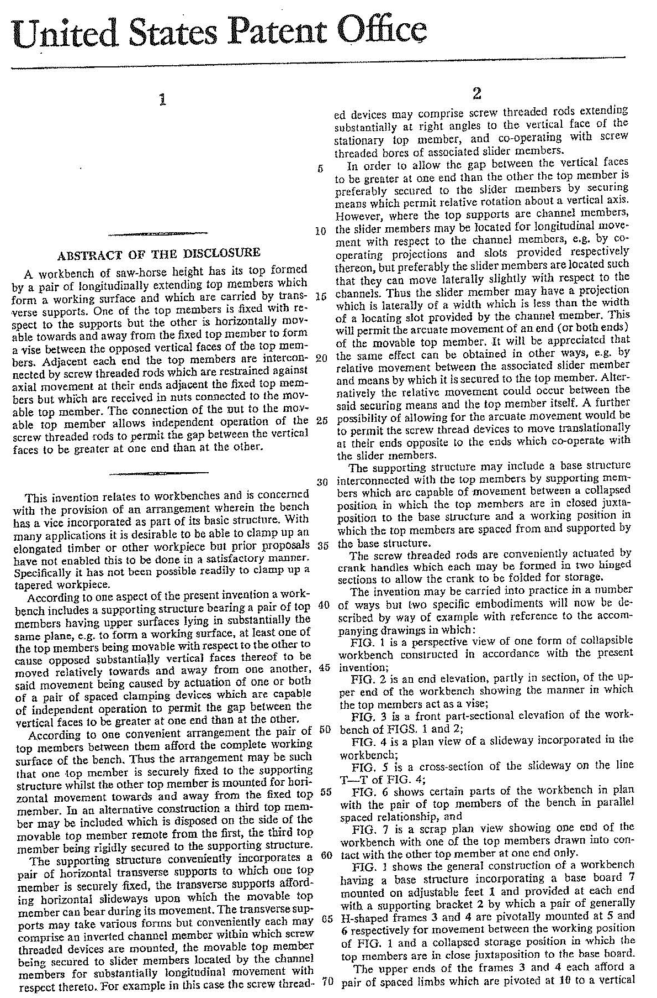

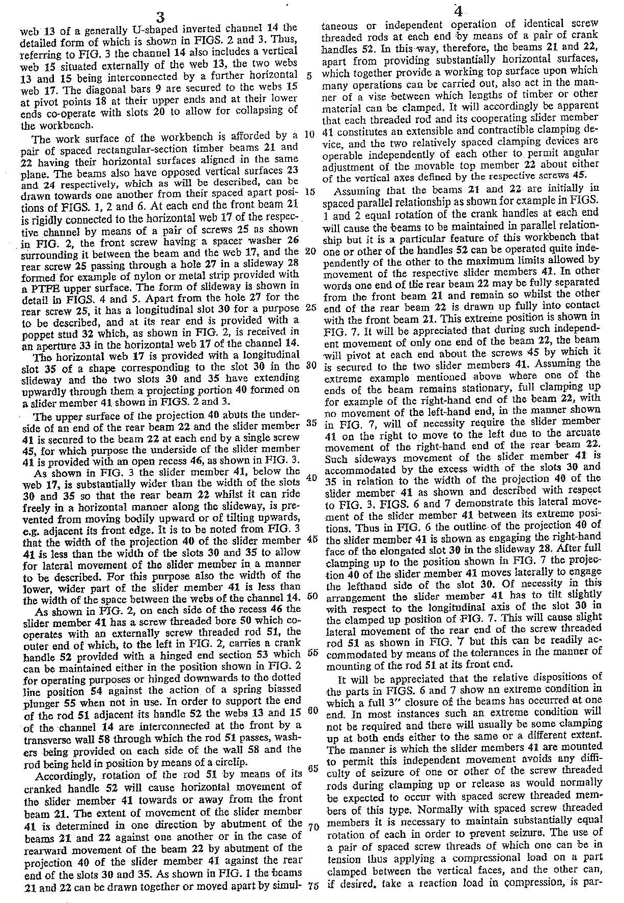

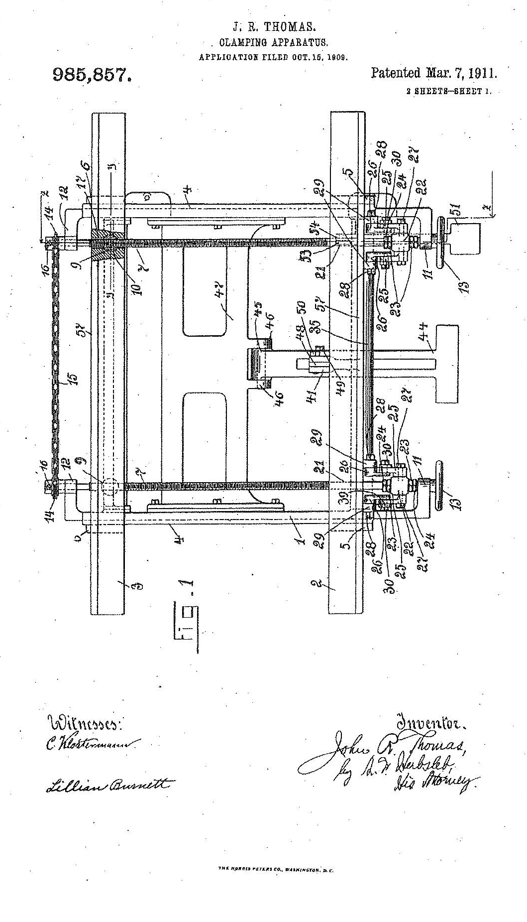

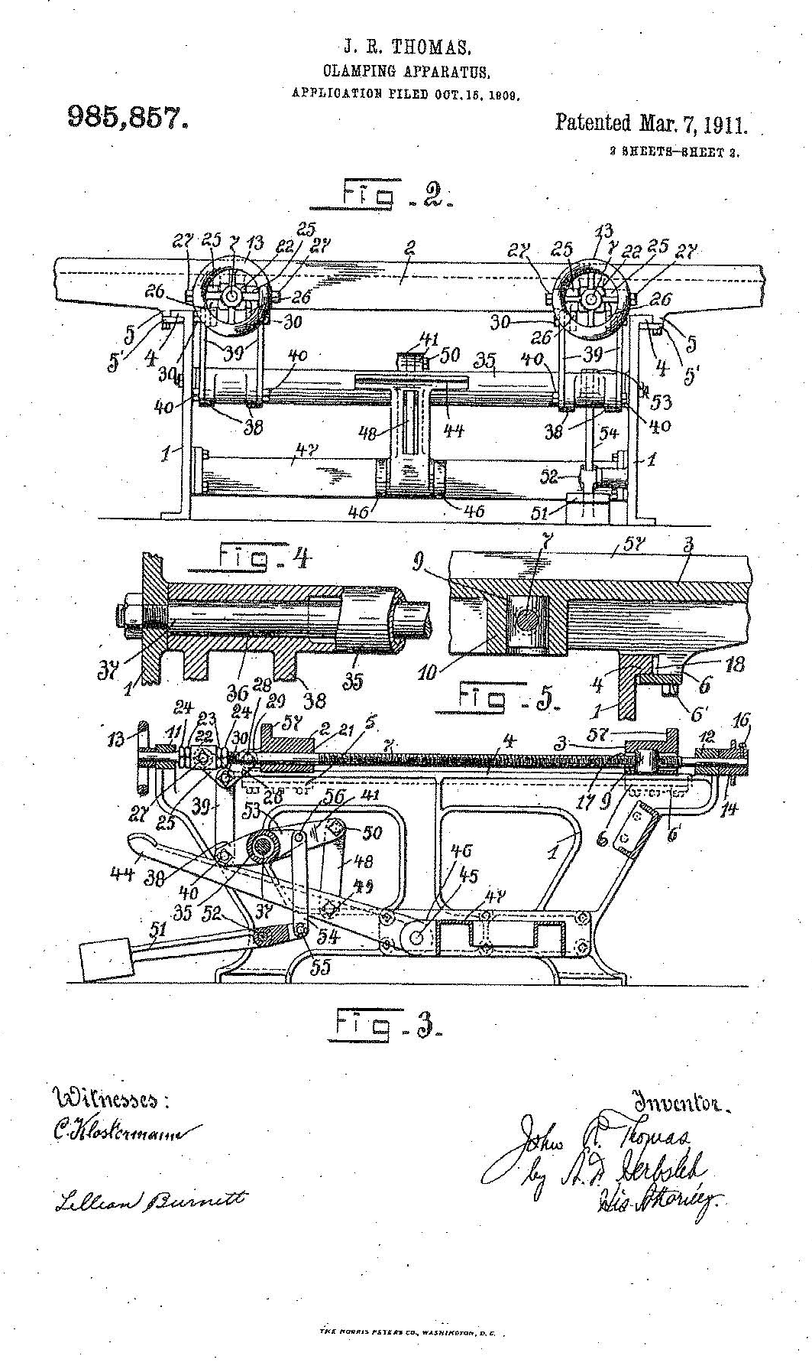

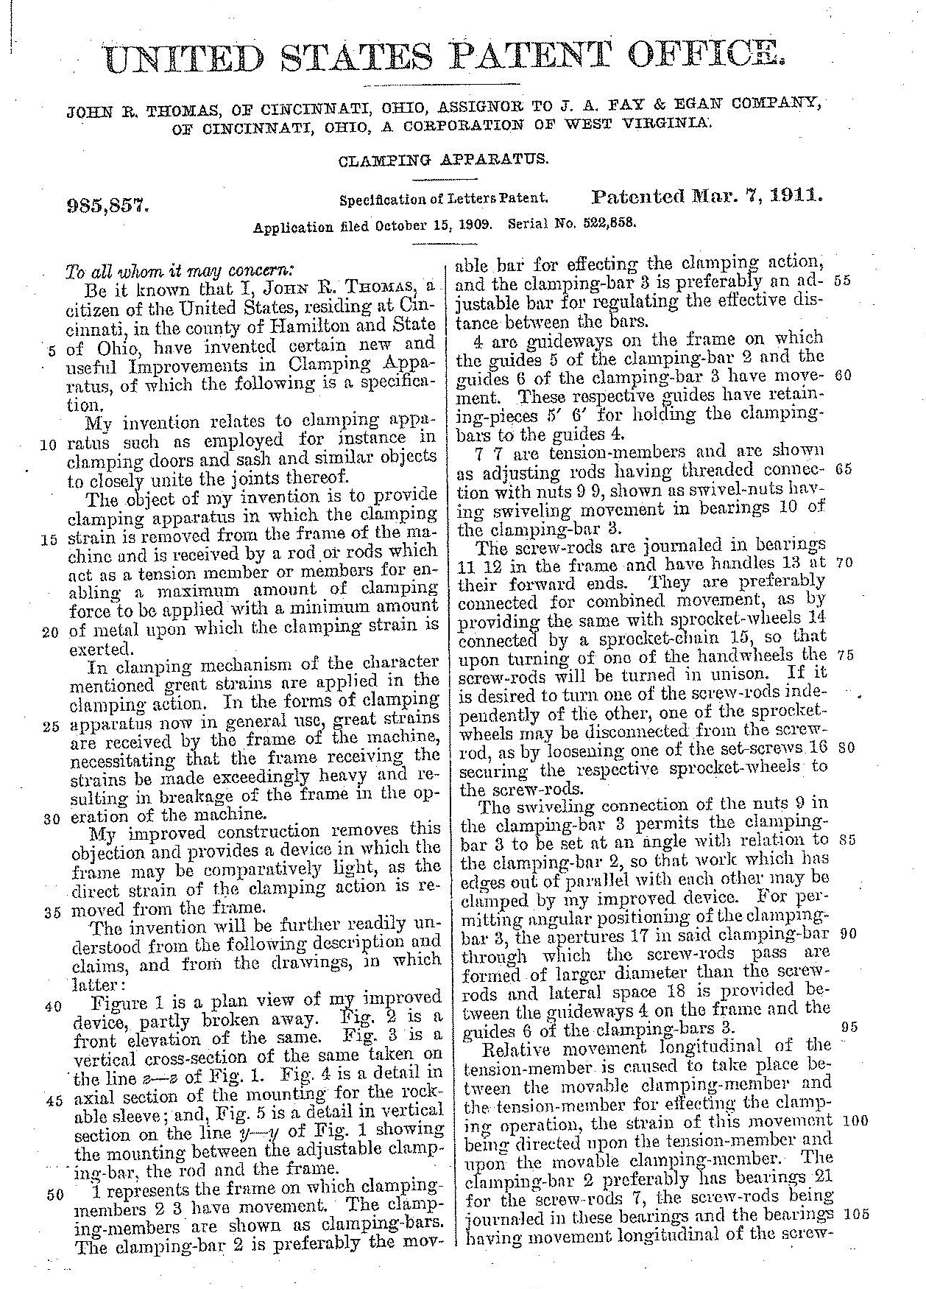

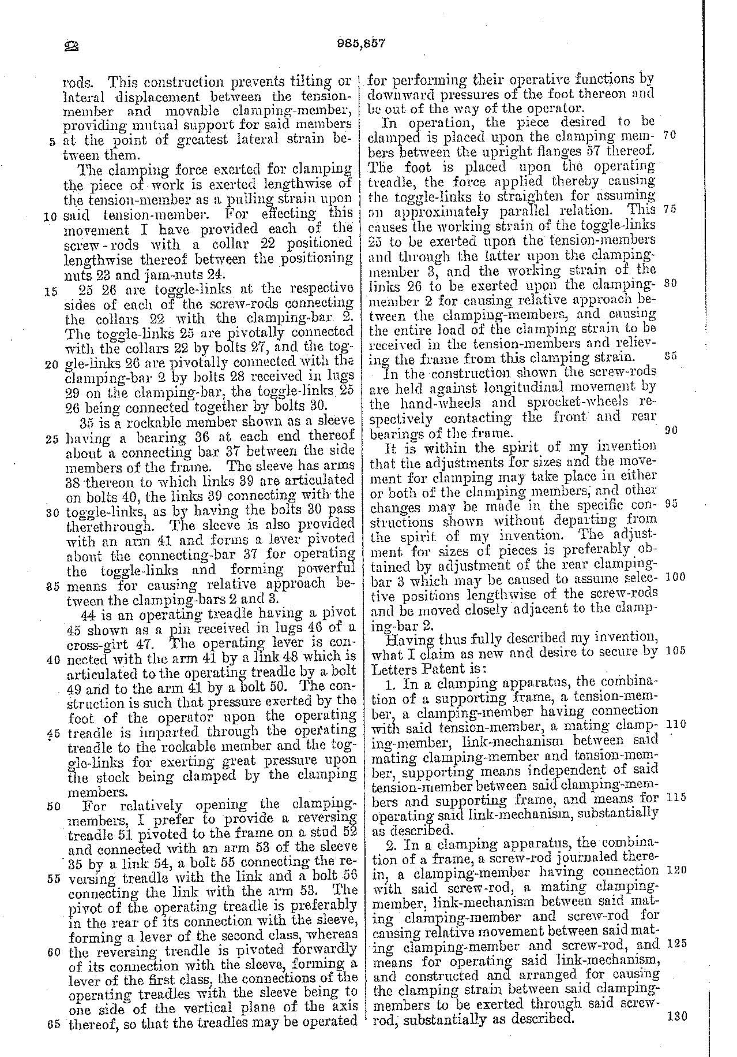

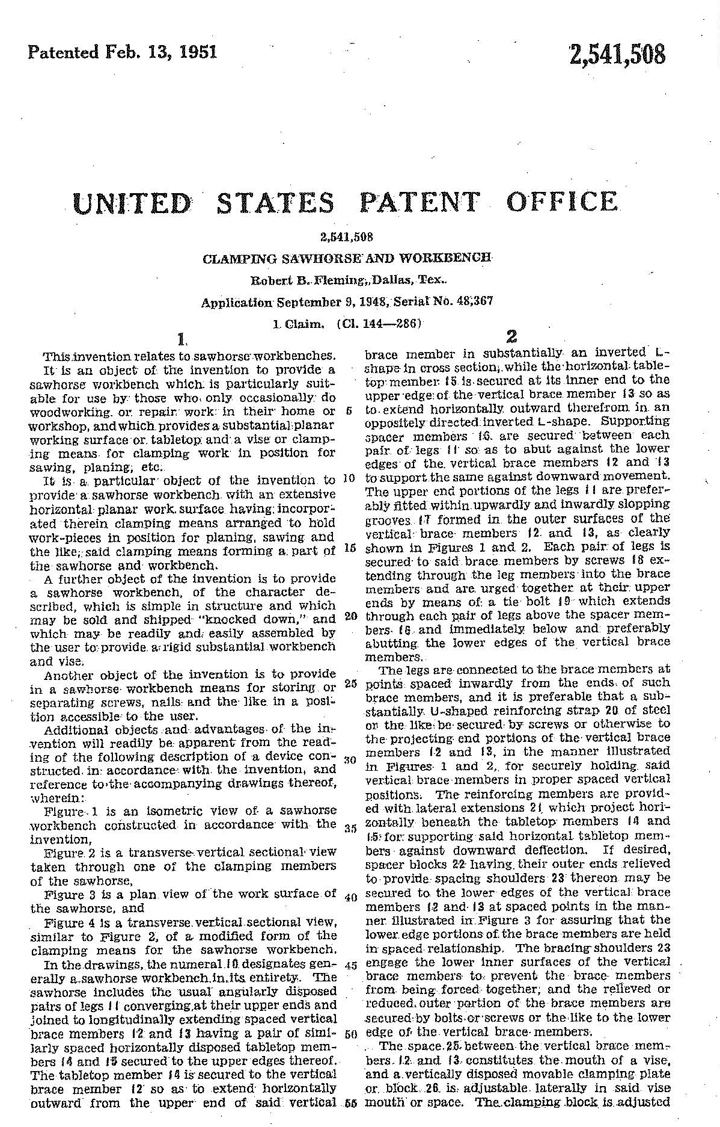

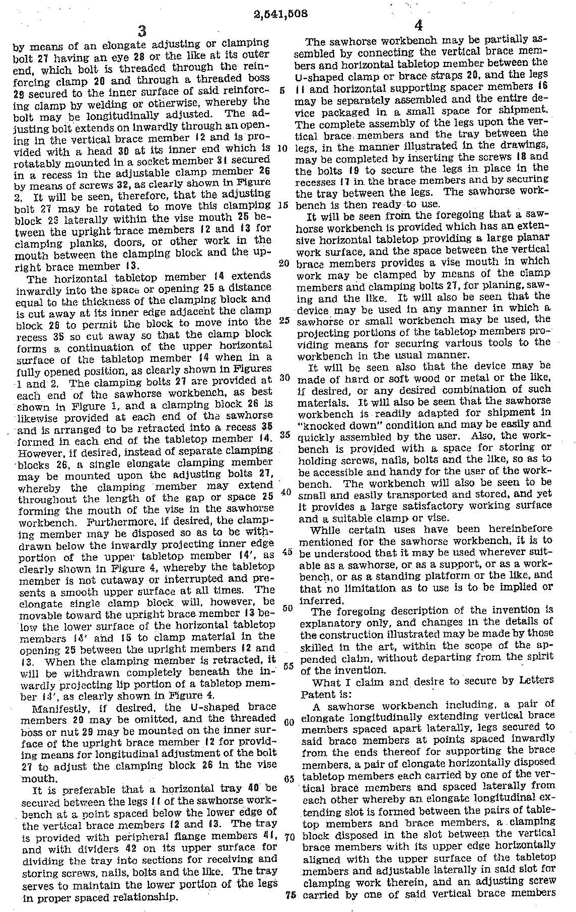

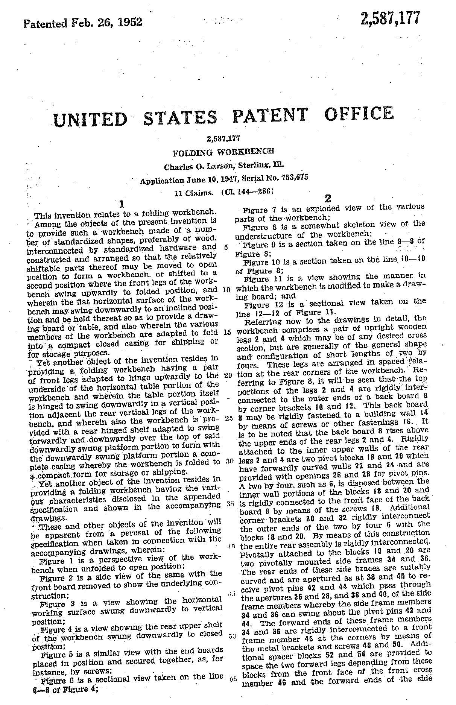

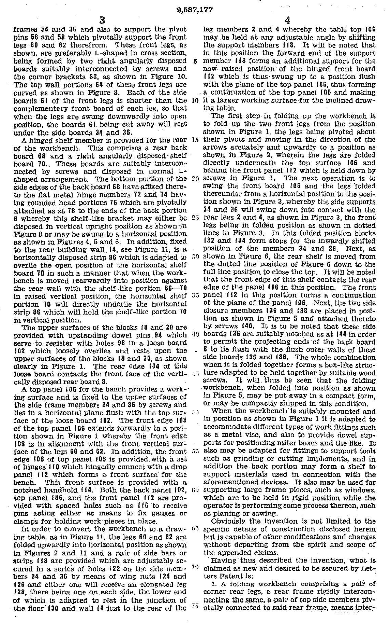

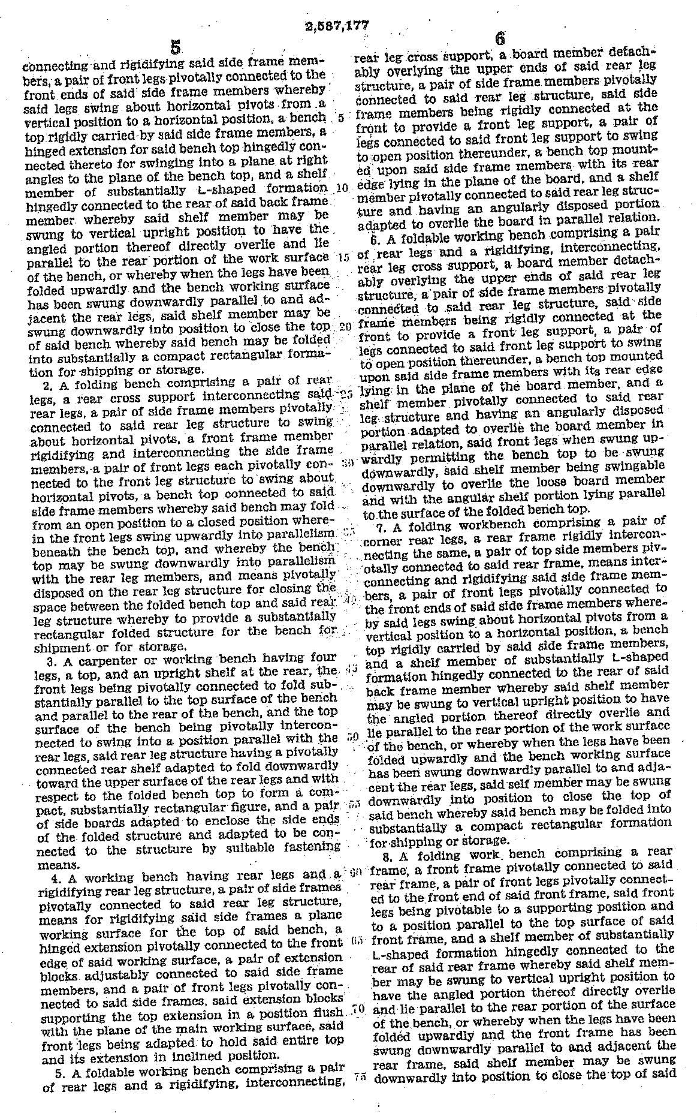

ADVANCED CLAIM DRAFTING AND AMENDMENT WRITING WORKSHOP
ELECTROMECHANICAL SECTION
HOMEWORK PROBLEM II

The attached specification and drawings disclose a push button electric switch.

The Finegan and Tsen et al. prior art references are also supplied so that you can write a broad claim that is distinguishable from the prior art.

Prepare a set of claims, including at least one broad independent claim covering the novel features of the invention.

Before beginning claim preparation, review all the patent disclosures, in order that you might direct the claims to the distinguishing features.

